Project Design Phase-II
Data Flow Diagram & User Stories

Date | 03 July 2026
Team ID
Project Name | Cosmetic Insights: Navigating Cosmetics Trends and Consumer Insights with Tableau
Maximum Marks | 4 Marks

Data Flow Diagrams:
A Data Flow Diagram (DFD) is a traditional visual representation of the information flows within a system. A neat and clear DFD can depict the right amount of the system requirement graphically. It shows how data enters and leaves the system, what changes the information, and where data is stored.
Example: DFD Level 0 (Industry Standard)
Example: (Simplified)

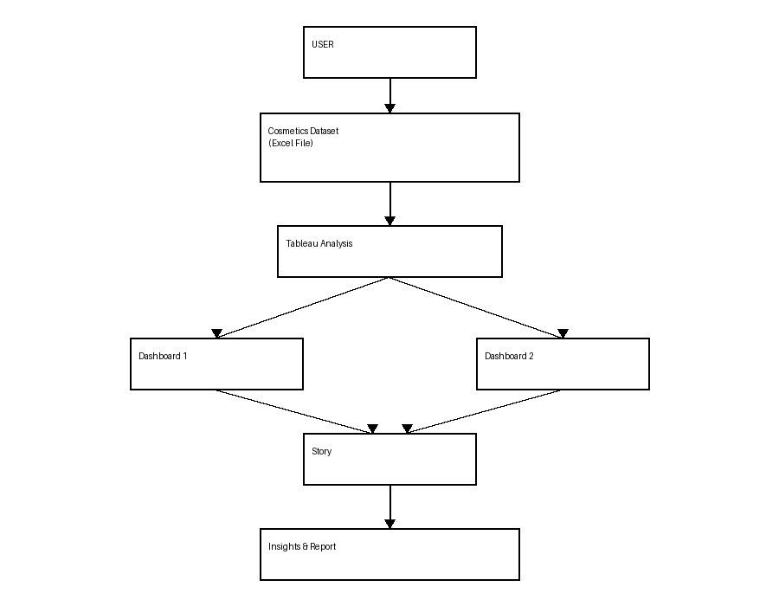

User Stories
Use the below template to list all the user stories for the product.
User Type | Functional Requirement (Epic) | User Story Number | User Story / Task | Acceptance criteria | Priority | Release
Customer (Web User) | Dashboard | USN-1 | As a user, I can view cosmetic dashboards | Dashboard displays successfully | High | Sprint-1
Customer (Web User) | Brand Analysis | USN-2 | As a user, I can compare cosmetic brands | Brand comparison is shown | High | Sprint-1
Customer (Web User) | Price Analysis | USN-3 | As a user, I can analyze product prices | Price charts are displayed | High | Sprint-1
Customer (Web User) | Skin Type Analysis | USN-4 | As a user, I can view skin-type insights | Skin-type visualization is available | Medium | Sprint-1
Administrator | Data Management | USN-5 | As an admin, I can manage cosmetic data | Dataset updates successfully | High | Sprint-2

